|  |  |  |
| --- | --- | --- |
| https://upload.wikimedia.org/wikipedia/commons/thumb/4/4e/VU_Logo.png/260px-VU_Logo.png | Computer Architecture and Assembly Language Programming (CS401)  Assignment No. 1  (Solution) | Total marks = 20  Deadline Date  May 18, 2021 |
| Please carefully read the following instructions before attempting assignment.  RULES FOR MARKING  It should be clear that your assignment would not get any credit if:   * The assignment is submitted after the due date. * The submitted assignment does not open or file is corrupt. * Strict action will be taken if submitted solution is copied from any other student or from the internet.   You should concern the recommended books to clarify your concepts as handouts are not sufficient.  You are supposed to submit your assignment in .doc or docx format.  Any other formats like scan images, PDF, zip, rar, ppt and bmp etc. will not be accepted.  Lectures covered: 1-6  Topics covered: Indirect Addressing | | |
| NOTE  No assignment will be accepted *after the due date via email in any case* (whether it is the case of load shedding or internet malfunctioning). Hence refrain from uploading assignment in the last hour of the deadline. It is recommended to upload solution file at least two days before its closing date.  If you find any mistake or confusion in the assignment (Question statement), please contact your instructor before the deadline. After the deadline, no queries will be entertained in this regard.  For any query, feel free to email at [cs401@vu.edu.pk](mailto:cs401@vu.edu.pk) | | |

**Q. Write an assembly language program to add all the digits of your VUID and store the sum in memory.**

* **Store all the digits of VUID in the memory.**
* **Use loop and jumps to add the digits.**
* **If the number is 0 then the program should not add that digit and move to the next digit.**
* **Store the sum in another variable.**

**Note: Make it sure to use your own VUID, otherwise zero marks will be awarded.**

**Submission details:**

**Following are required in a single MS-Word document.**

* **Assembly language program.**
* **Screenshot of AFD debugger at the start of program.**
* **Screenshot of AFD debugger showing the final values.**

**Solution:**

**[org 0x0100]**

**mov bx, num1 ; point bx to first number**

**mov cx, 9 ; load count of numbers in cx**

**mov ax, 0 ; initialize sum to zero**

**l1: cmp word [bx],0**

**jz l2**

**add ax, [bx] ; add number to ax**

**l2: add bx, 2 ; advance bx to next number**

**sub cx, 1 ; numbers to be added reduced**

**jnz l1**

**mov [total], ax ; write back sum in memory**

**mov ax, 0x4c00 ; terminate program**

**int 0x21**

**num1: dw 1, 2, 0, 4, 0, 1, 4, 2, 9**

**total: dw 0**

**Screen Shot 1**

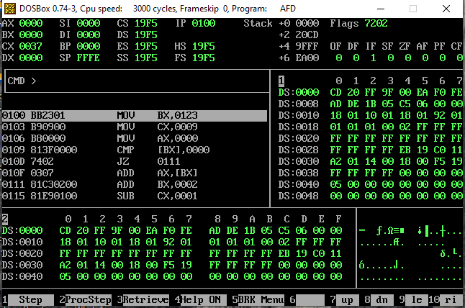 **Screen Shot 2**

